**Assignment 2: Pokematch in UNITY**

**AIM:** You are requested to program a memory game called pokematch in Unity 2D.

**SOLUTION:** I have used the first reference provided by Dr. Sabah Mohammed to complete this assignment

<http://theflyingkeyboard.net/unity/memory-game-tutorial-part-1-cards/>

We have to create 4 scenes in this game. One for menu screen, one for each of 3 levels of difficulty i.e. Easy, Medium, and Hard.

***TO RUN THE GAME, OPEN POKEMATCH.EXE FROM EXE FOLDER***

**MENU:**

In menu scene we add four buttons. Three of these buttons are to choose difficulty level and fourth button is to exit the game. We add UIButtonQuitGame.cs and UIButtonLoadLevel.cs scripts on the buttons.

**EASY:**

* We start with adding a suitable background to the game level.
* We add multiple empty objects like game controller, card spawner, card selector, win etc.
* Win is disabled and enables only when the level is complete. Game manager script controls the whole game.
* We add all the cards sprites in the sprite folder.
* We create prefabs of all the cards and then add these prefabs to prefabs folder and remove the cards from the scene.
* We add CardController script to card prefabs.
* GameManager script controls how we play the game. It checks that only two cards can be flipped at a time. Then it checks if the two cards flipped match. If they do, these cards are removed from the scene. If they don’t match, cards are flipped back.
* CardSpawner script as the name implies is used to spawn cards. It takes cards prefabs and spawn them according to row and column count. We add an empty object SpawnStartingPoint which is used to initialize the first card location.

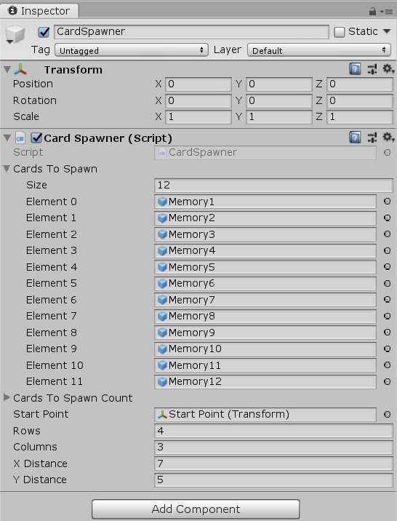

* Then we add Time and game scoring. Time is added as a text on canvas. We add time controller script on it to increment time on every second.
* Game scoring is done by decreasing score after every second and awarding some points on every successful card match.
* On successful match of all the cards win canvas is enabled which shows player his score and give him option to restart the game or go to the menu screen.
* **Medium and Hard Levels are created using the same above steps just changing the arguments in card Spawner.**

**SCREENSHOTS:**

* We start the game by opening PokeMatch.exe from EXE folder.

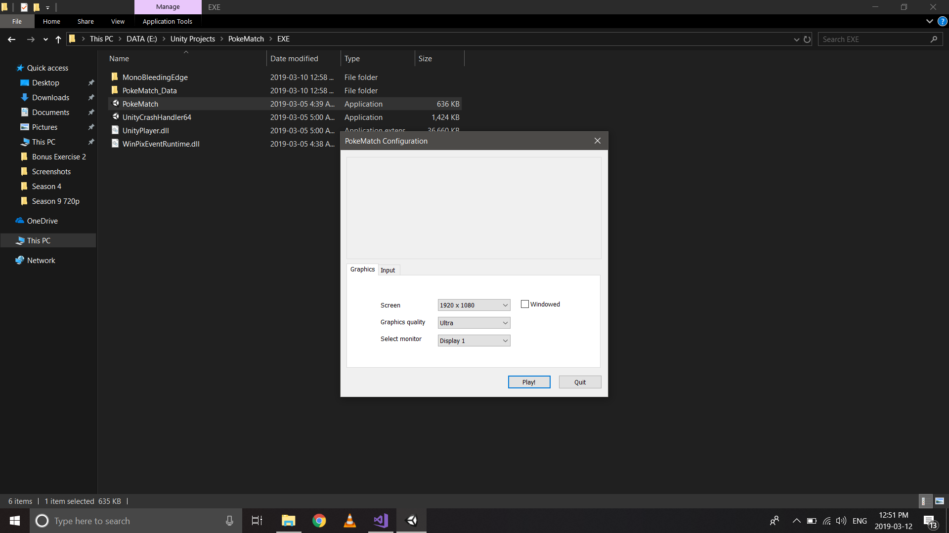

* MENU Screen

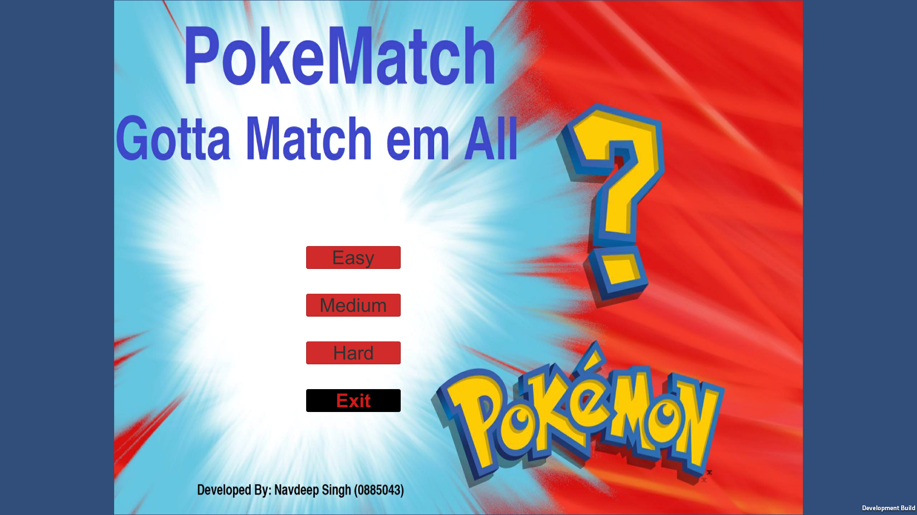

* Easy Mode: 12 Cards and 6 pairs to match

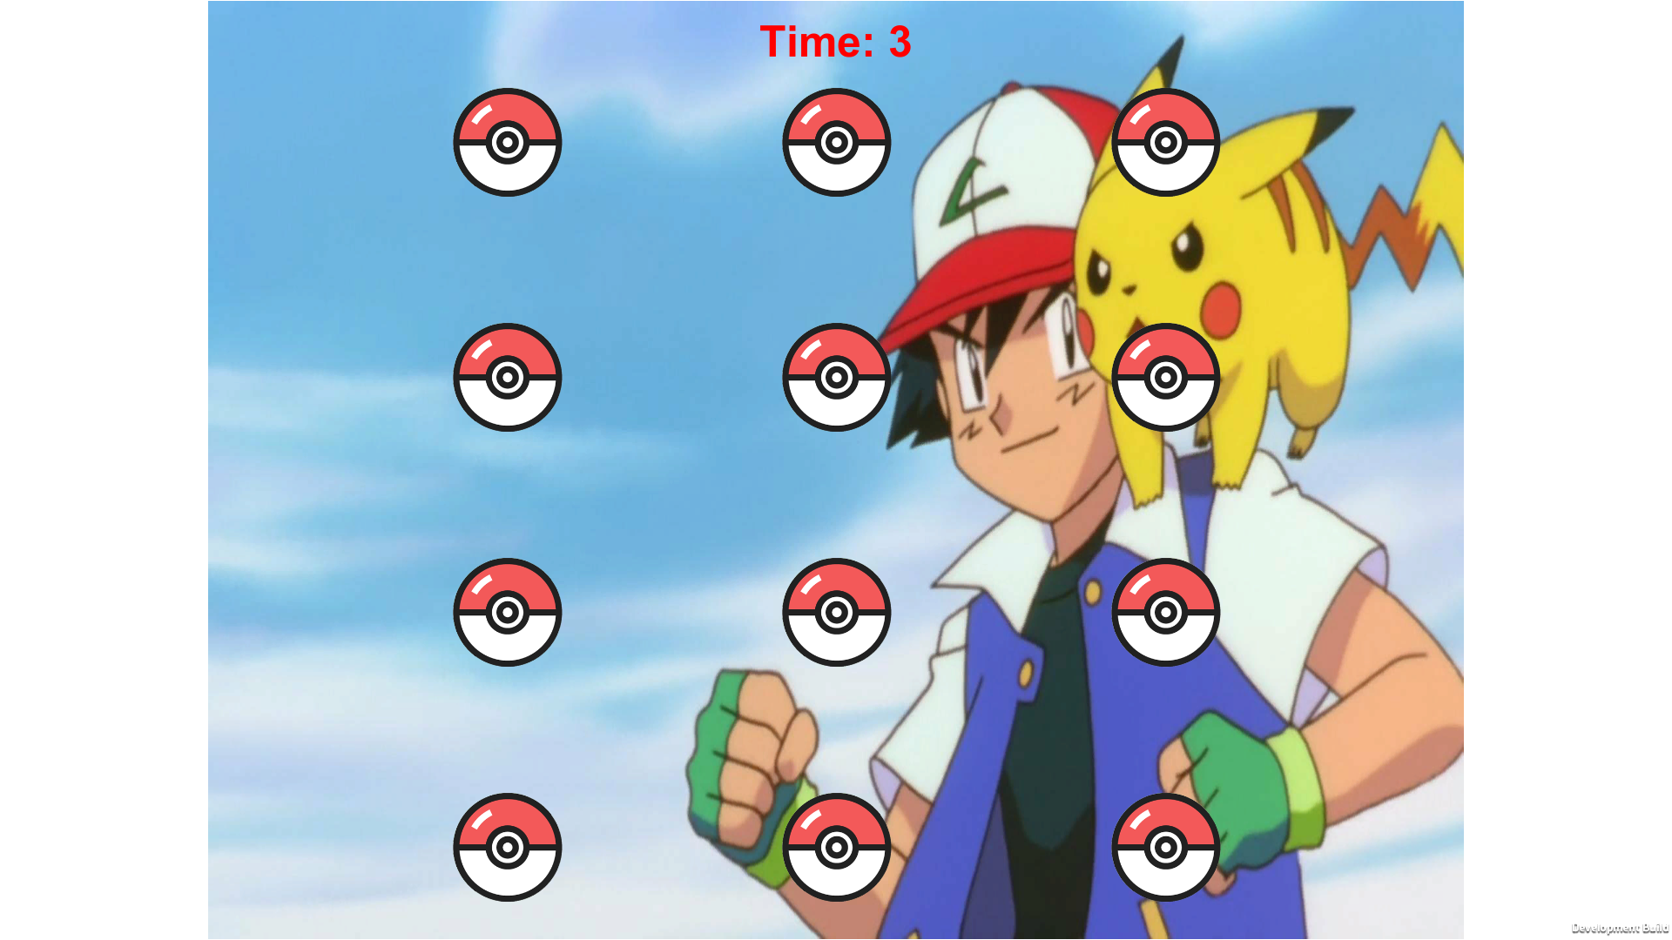

* Opening card by clicking on it

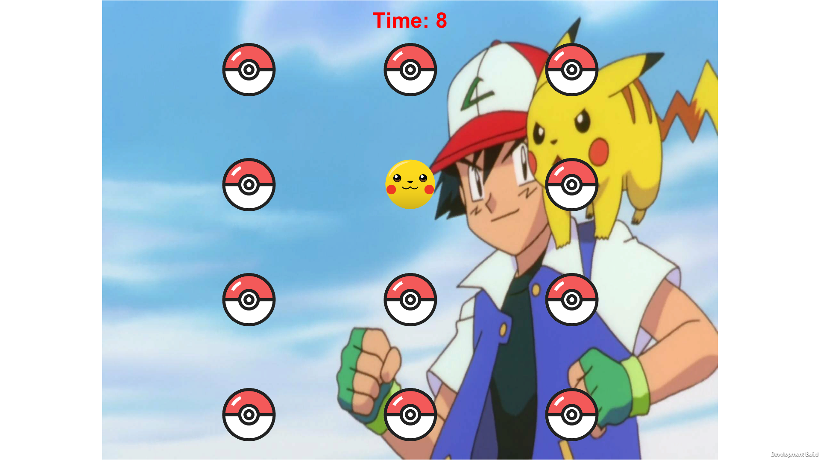

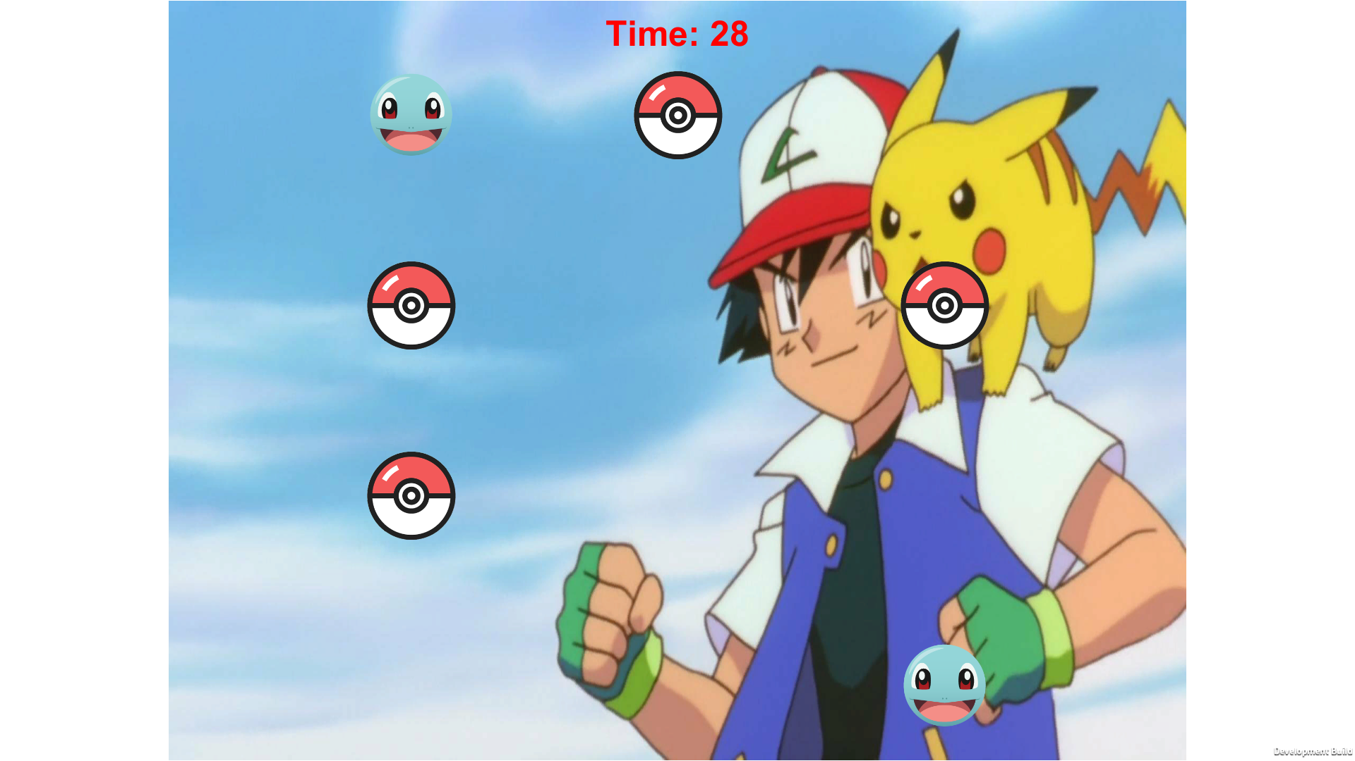

* Last card pair to match.

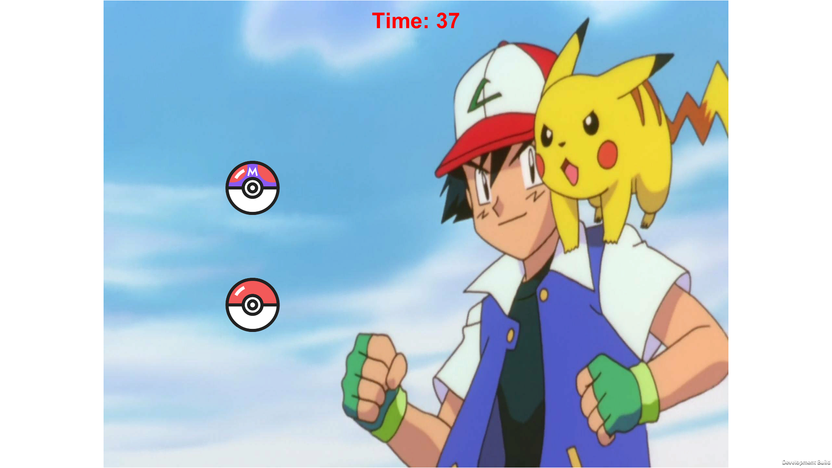

* Easy Mode Completion Screen

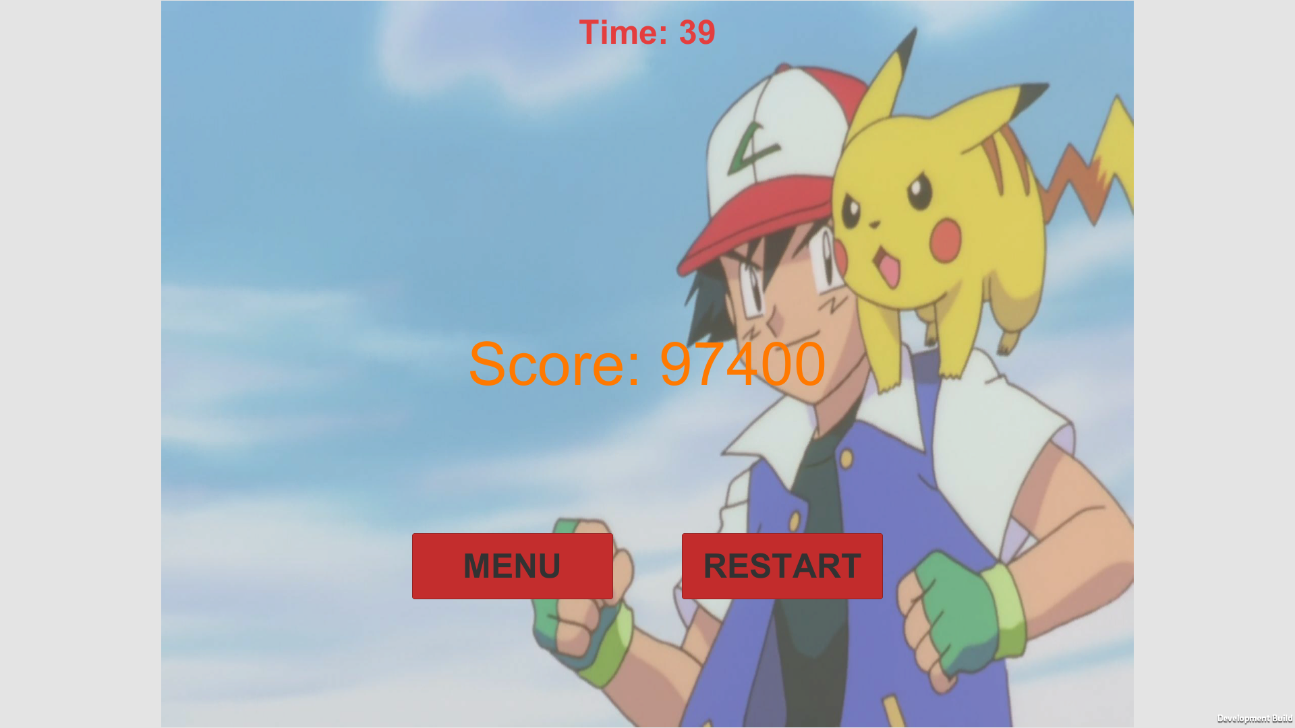

* Medium Difficulty mode: 16 cards, 8 cards pair to match

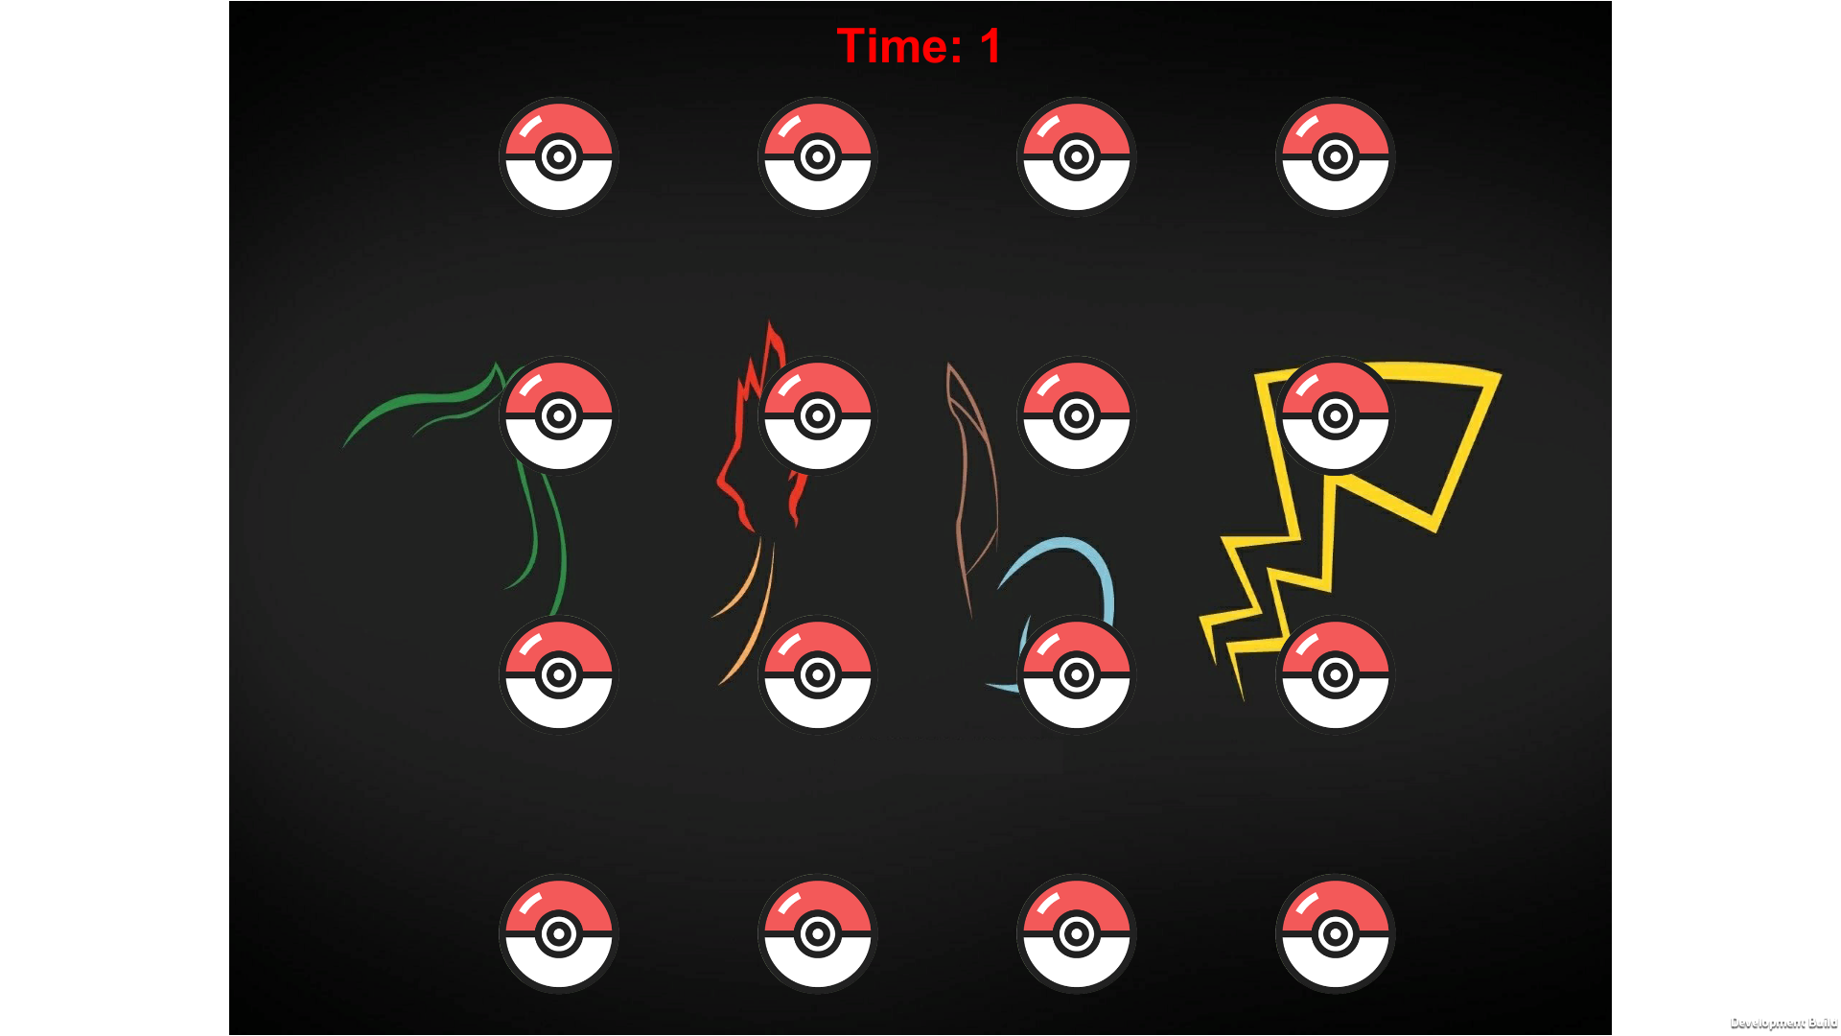

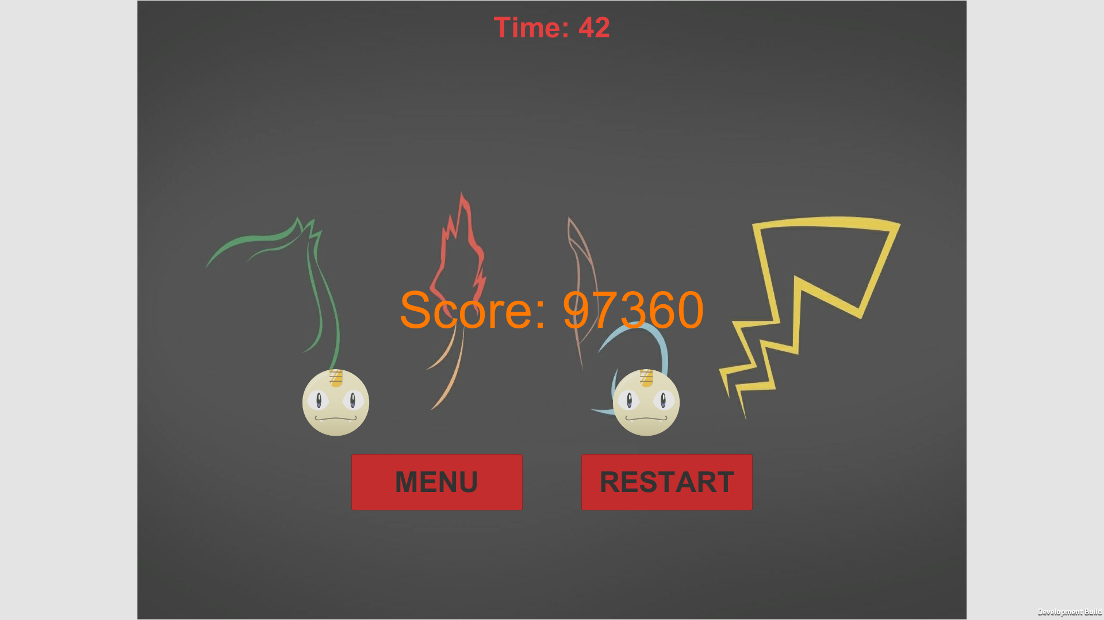

* Hard Difficulty Mode: 24 cards, 12 pairs to match

